1. **Introduction**

The motivation of this study is to identify a way to quantify the skill, aptitude,and quality of current NBA players to later determine if their addition to an NBA team would be beneficial. When we mention quality, we are referring to overall win percentage of the players, or amount of accolades received, or when a valuable skill set is produced. The main variables we will be using are points, height, and salary to identify correlation in regards to quality. In the final analysis, we hope to see if the aforementioned variables have some causation into the overall quality of basketball players.

**Data Exploration via Graphical Display**

Single Variable Section

To begin with, we start with a bar graph for height.

HEIGHT BAR GRAPH

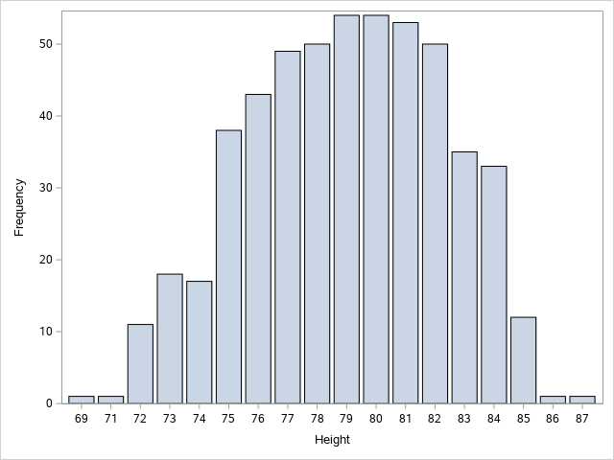

This graph depicts that large heights is a desirable attribute in the NBA. 6’7 ft is the average height of an NBA player, while the average height of the average male is 5’10. Therefore, this factor would likely result in the overall quality of the player.

Here we display a histogram for NBA player salaries

HISTOGRAM FOR NBA SALARIES

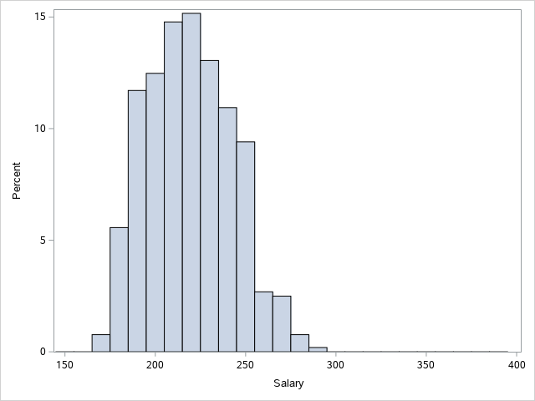

The histogram shows the distribution of salaries. It would seem that those who are given a larger salary are predicted to perform better in the NBA, thus pointing to a higher quality player.

Here we display a histogram for points

HISTOGRAM FOR POINTS

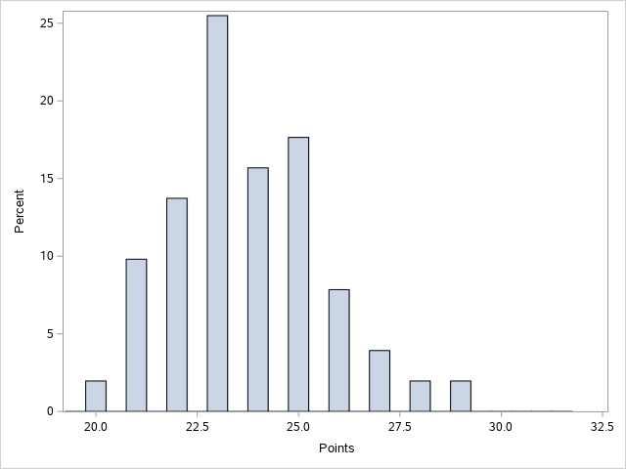

The histogram shows the distribution of points made by players. We singled out this graph to put emphasis on the fact that a certain level of scoring is deemed desirable, thus pointing to a higher quality player.

MULTI VARIABLE SECTION

To attempt to find correlation we created a bar graph to compare both height and points

HEIGHT AND POINTS BAR GRAPH

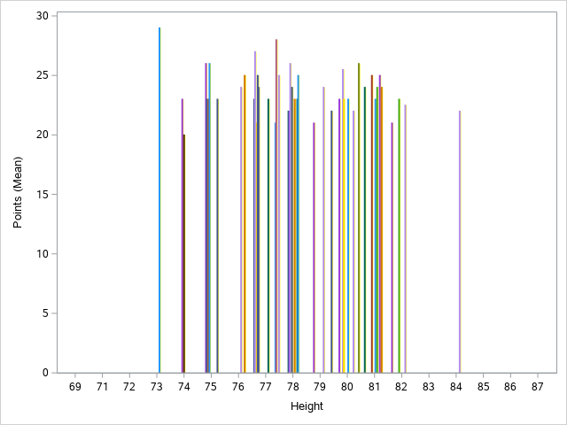

The graph doesn’t show a statistically significant comparison worth noting. The graph seems to be evenly skewed giving it a uniform distribution.

Here, we display a scatterplot which combines points and salaries

POINTS AND SALARIES SCATTERPLOT

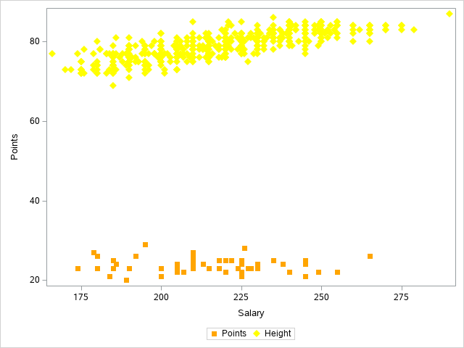

With the scatterplot we attempted to establish a relationship between points scored and salary received. We hoped to see if there was any correlation that pointed to the overall quality of the player

III. Data Description via Numerical Summaries

In this table we attempt to find some type of central tendency within height and points.

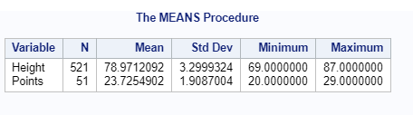

Judging from the data, there is no clear sign of direct statistically significant correlation between the two variables.

Here, we attempt to find correlation between points and salaries.

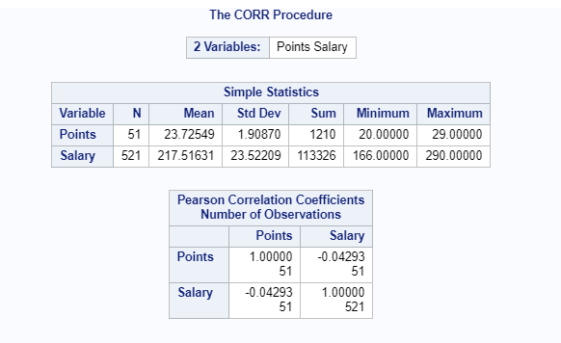

Judging from the data, we believe that those with a larger amount of points, tend to have a higher salary. Therefore, these two variables have the possibility of being statistically significant.

IV. Conclusion

In the final analysis it can be said that there is some correlation between points and salaries. Furthermore, there does not seem to be a huge correlation between height and salaries, along with height and points However, a correlation does not determine causation, so in order to determine which relationships are statistically significant, we will be testing out points and salaries in the next phase.